**RAPPORT du brief bdd-first-S**

Automatiser et Contrôler le nombre de commandes

ligne horizontale

# Exemple d'image

# Introduction

Autant que gérant du coffee_shop (l’entracte), j’aimerai bien avoir un système automatisé qui me permet d’enregistrer les clients et leurs commandes pour visualiser la date et le client qui a pris la commande, peut être au futur j’aimerai ajouter une promotion pour les clients fidèles

#2 what’s the SQL query that allow us to delete a column in a table

====> Une syntaxe permet également de supprimer une colonne pour une table. Il y a 2 manières totalement équivalente pour supprimer une colonne:

# ALTER TABLE nom_table

DROP nom_colonne

# ALTER TABLE nom_table

DROP COLUMN nom_colonne

#3 **‘Truncat’** : la commande TRUNCATE permet de supprimer toutes les données d’une table sans supprimer la table en elle-même

////APPLICATION \\\\

1- créer une table (truncat) avec 4 colums.

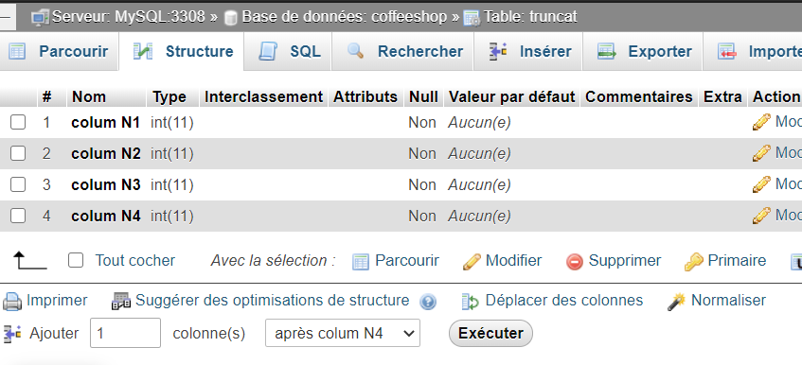

2- Il est possible de supprimer toutes les données de cette table en utilisant la requête suivante :

TRUNCATE TABLE `truncat`

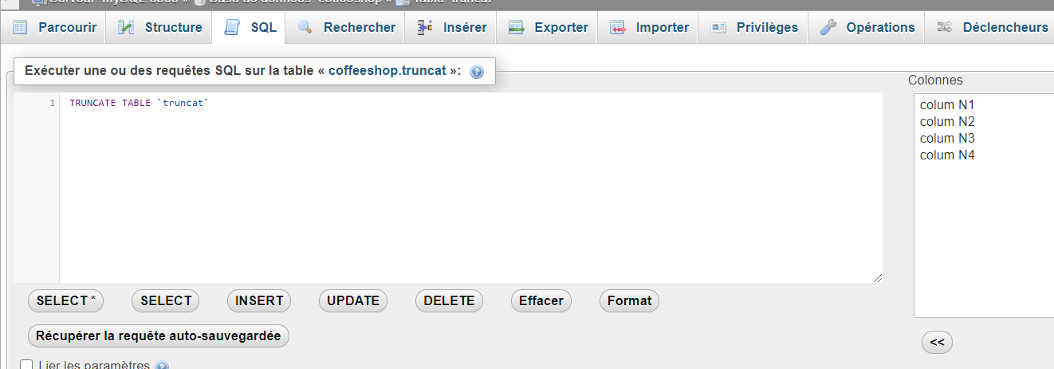

résultat :

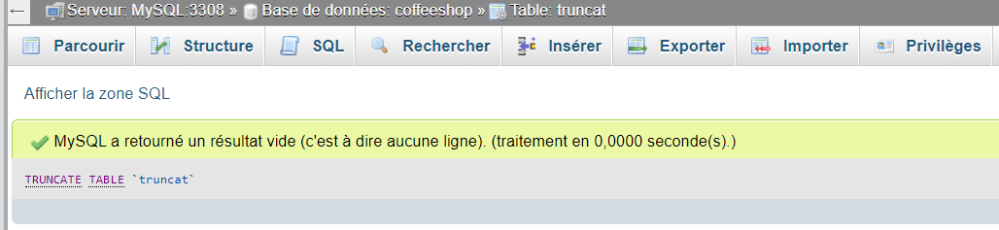



**PowerDesigner** (anciennement **PowerAMC)** :

est un [logiciel](https://fr.wikipedia.org/wiki/Logiciel) de conception créé par la société *SAP*, qui permet de modéliser les traitements informatiques et leurs [bases de données](https://fr.wikipedia.org/wiki/Base_de_donn%C3%A9es) associées.

***MCD:*** ***Modele Conceptuel Donnees***

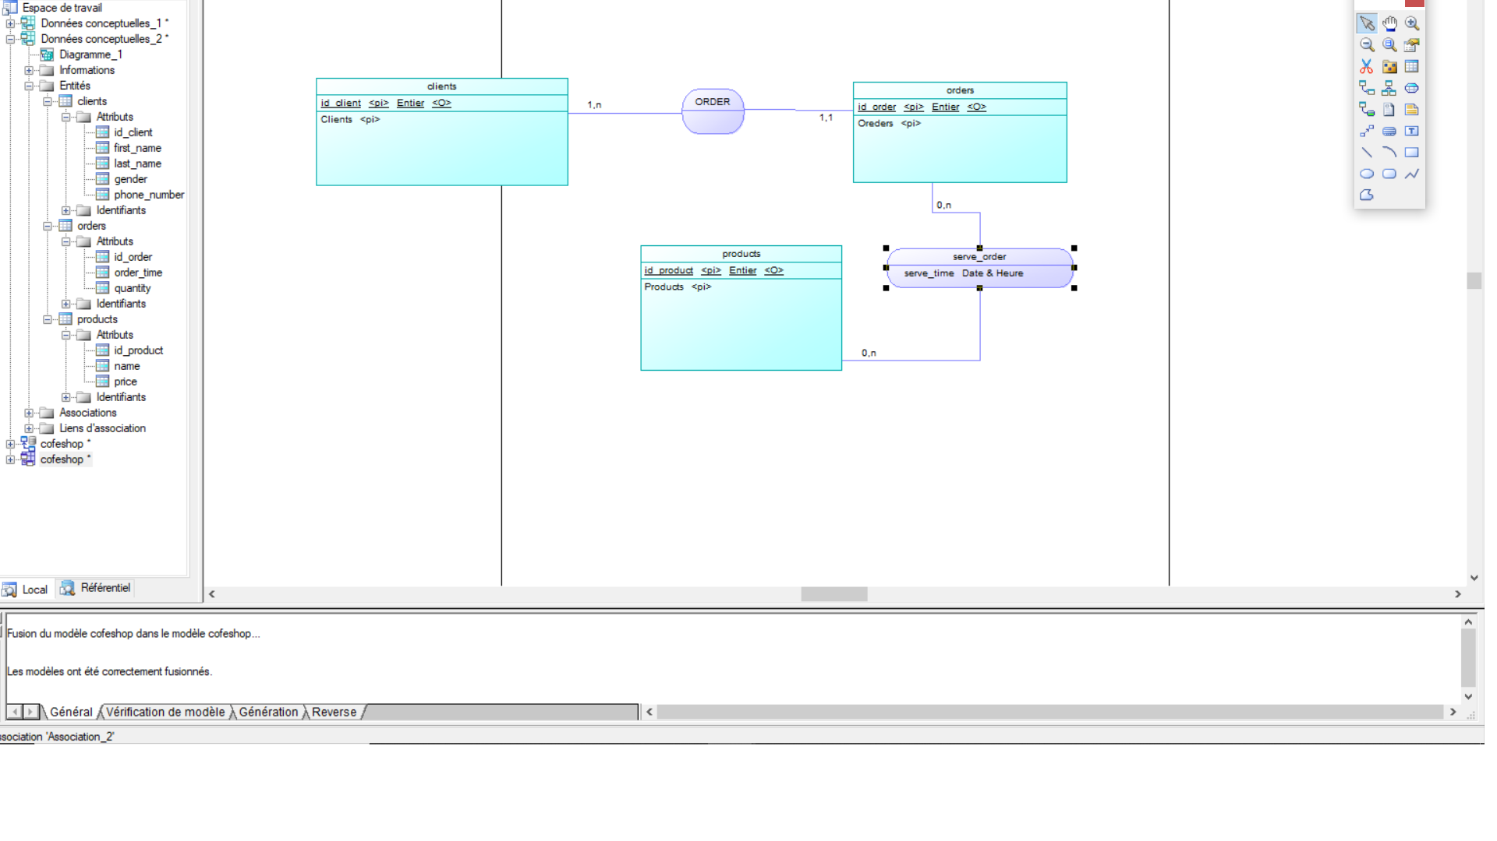

***MLD:*** ***Modele Logique Donnees***

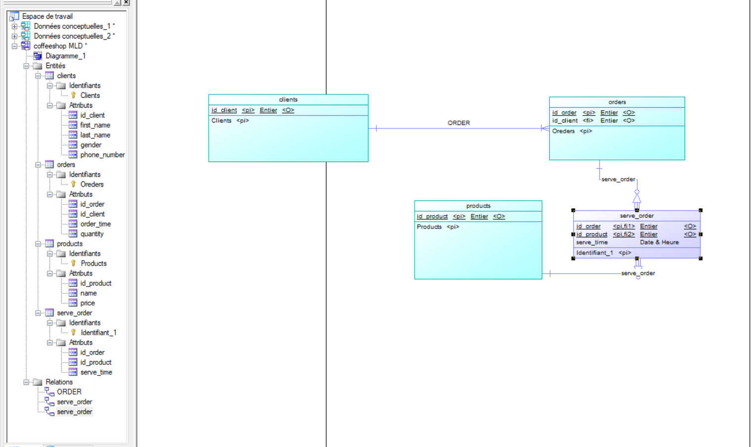

***MPD: Modele Physique Donnees***

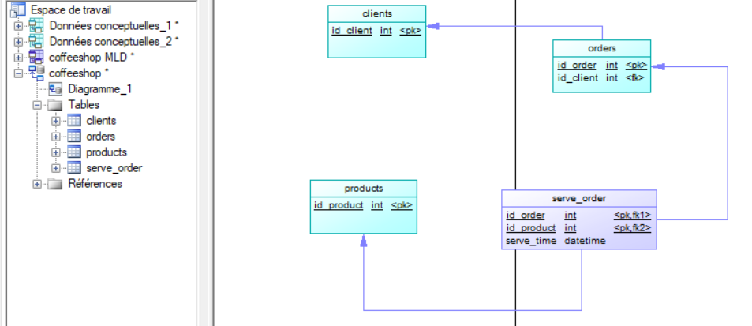

création base de donnée et création les tableau DLL :

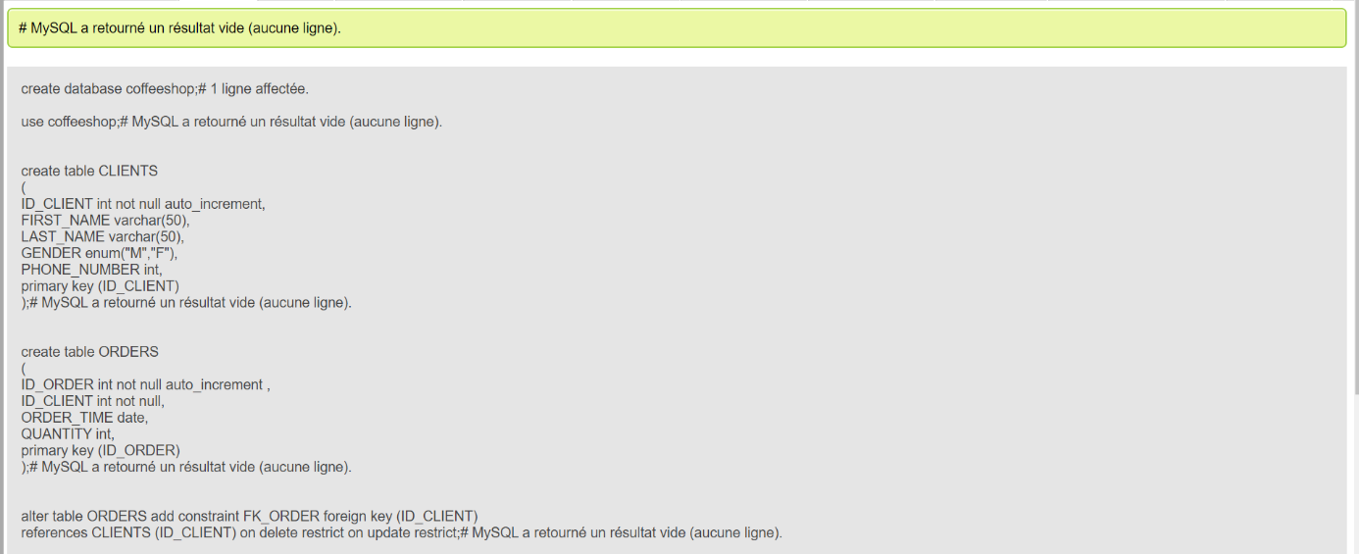

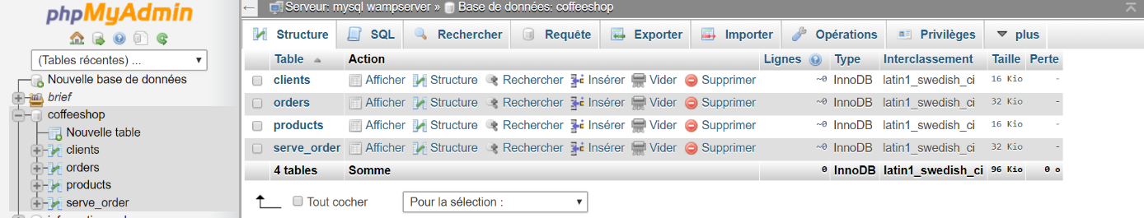

add a new column Product_origin varchar(50) :

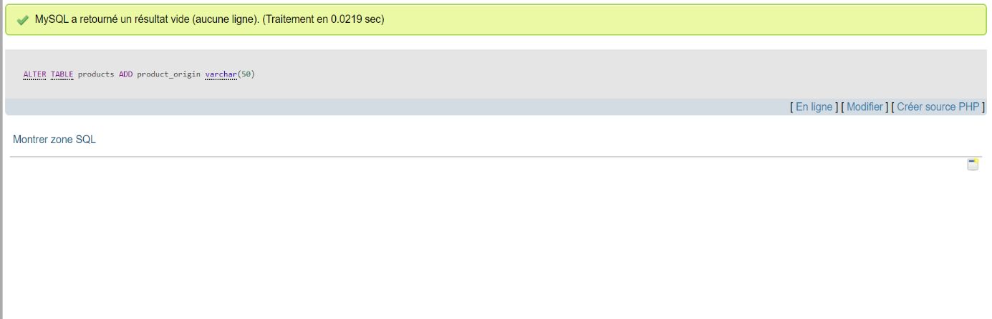

Add a unique constraint to the ‘first_name’ and ‘last_name’ column in clients table :

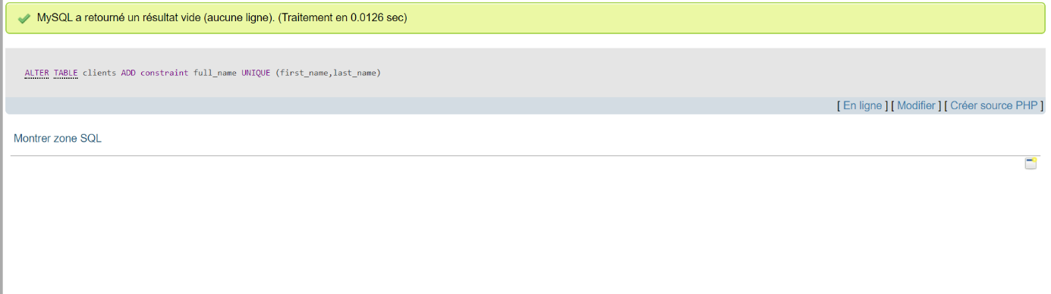

change the column name ‘order_tim’e to ’Date_order’ in the table ‘command’ and change the type to ‘DATETIME’

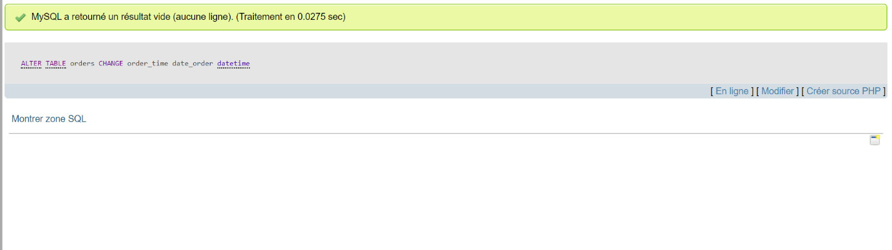

#6 delete the column ‘quantity’ from the table ‘command’ :

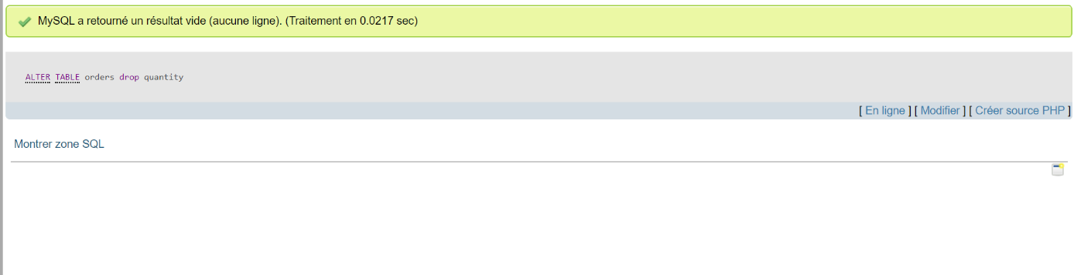

Insert those Data in the table Clients: ('Chris','Martin','M','01123147789'), ('Emma','Law','F','01123439899'), ('Mark','Watkins','M','01174592013'),...

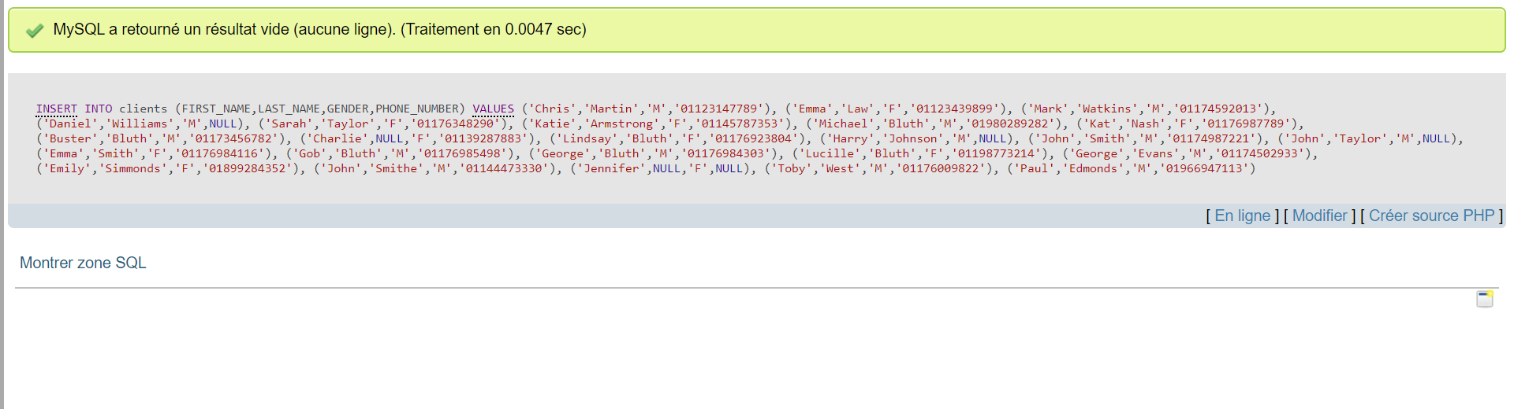

Insert those Data in the table command (1,1,'2017-01-01 08-02-11'), (1,2,'2017-01-01 08-05-16'), (5,12,'2017-01-01 08-44-34'),

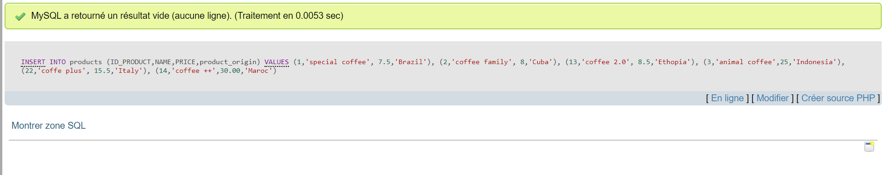

Insert those Data in the table command (1,'2017-01-01 08-02-11'), (2,'2017-01-01 08-05-16'), (12,'2017-01-01 08-44-34'), (4,'2017-01-01 09-20-02'),

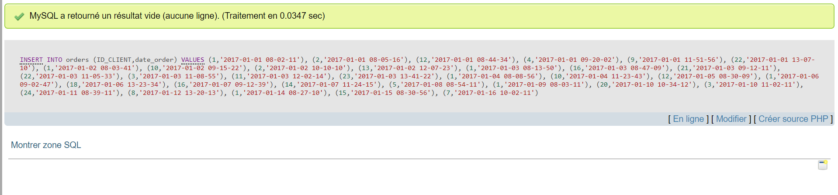

Price * 5 condition (product_name = special coffee)

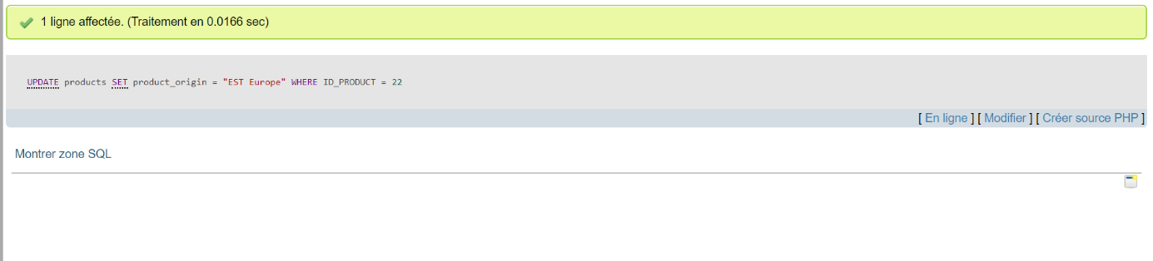

Coffee_orgin = EST Europe where id_product = 22

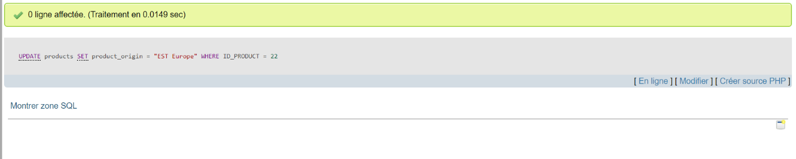

in the table command, Print the recent command ordered

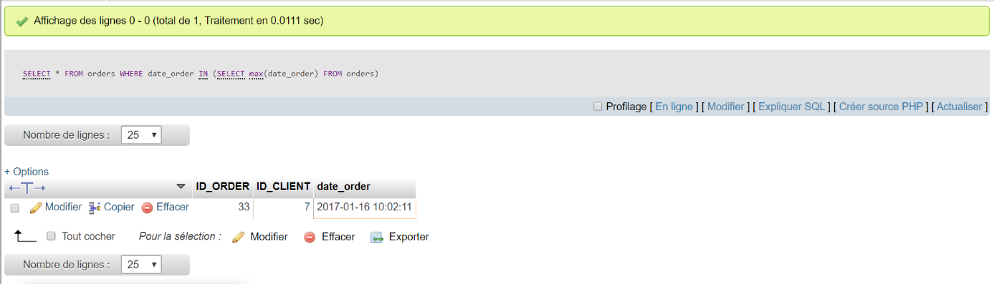

the customer who made the maximum of command

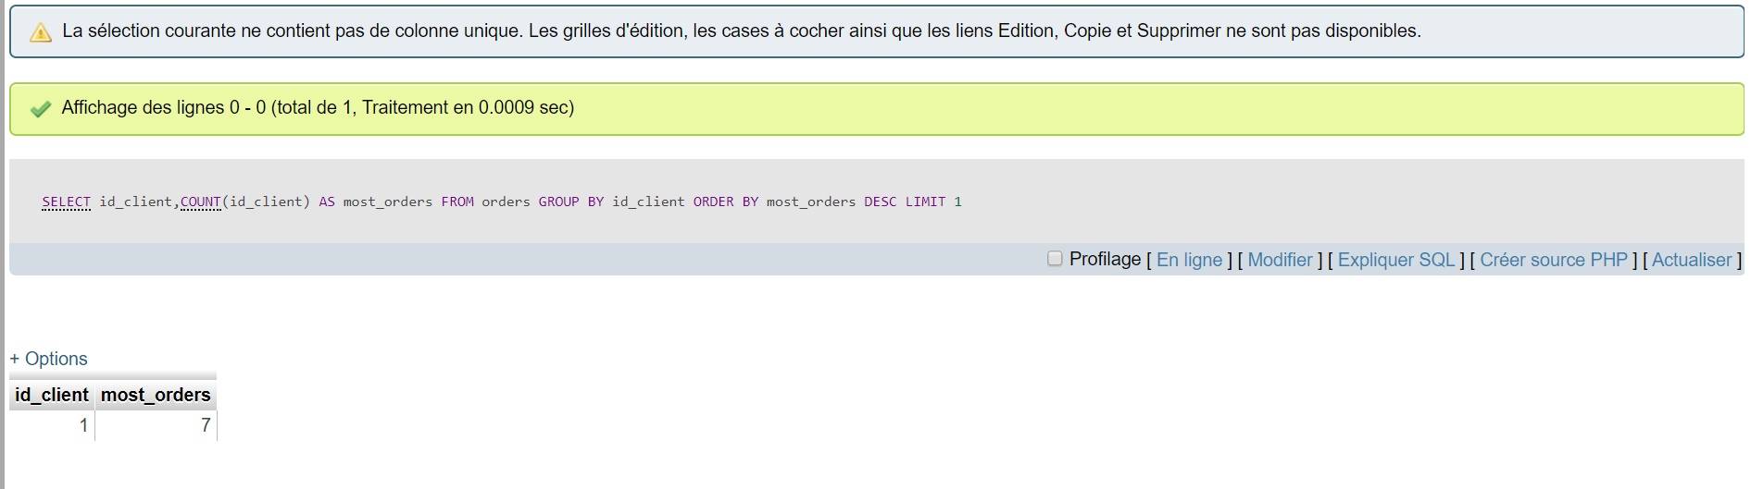

in the table clients print how many man and woman we have

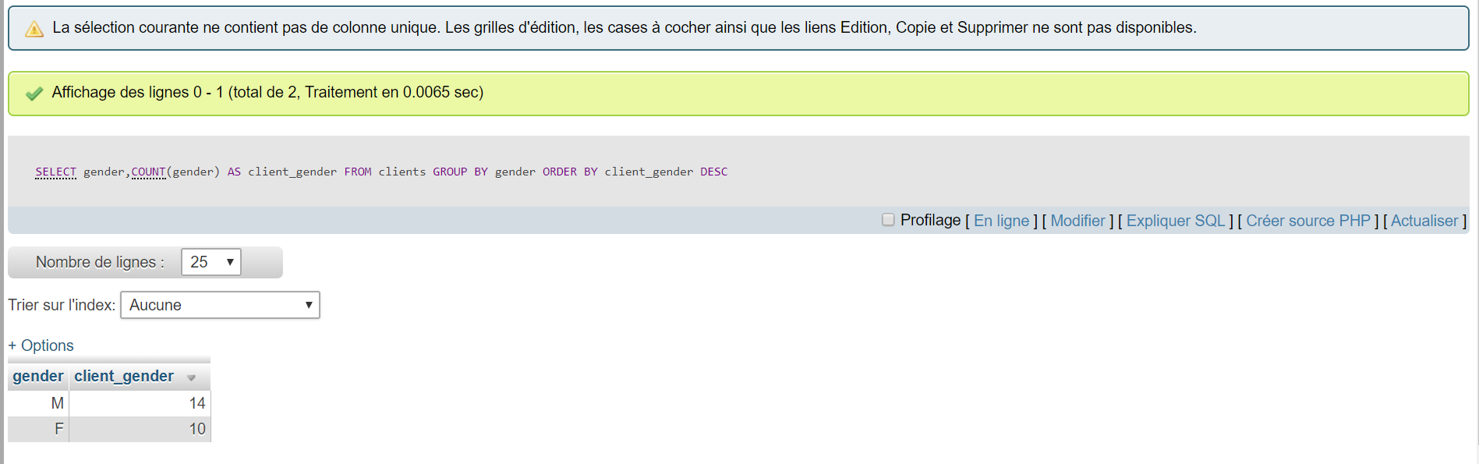

***#Step 4:***

#1 Select from the products Table the following:

* All the products which have the price above 15:
* SELECT * from products

where price > 15;

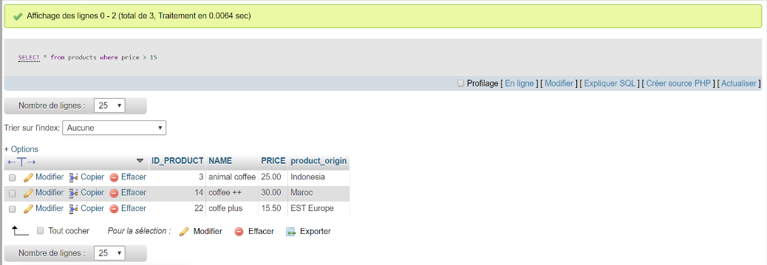

* The product name and the price which contains the sentence ‘special’:
* SELECT NAME,price from products

WHERE NAME like '%special%';

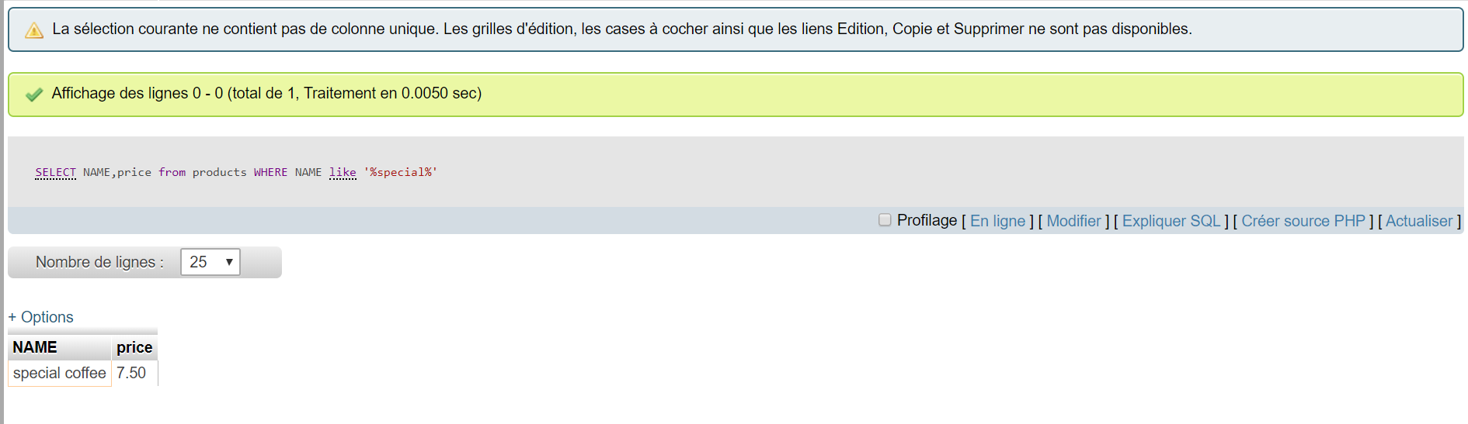

* Product name which price != 8.5:
* SELECT NAME from products

WHERE price !=8.5;

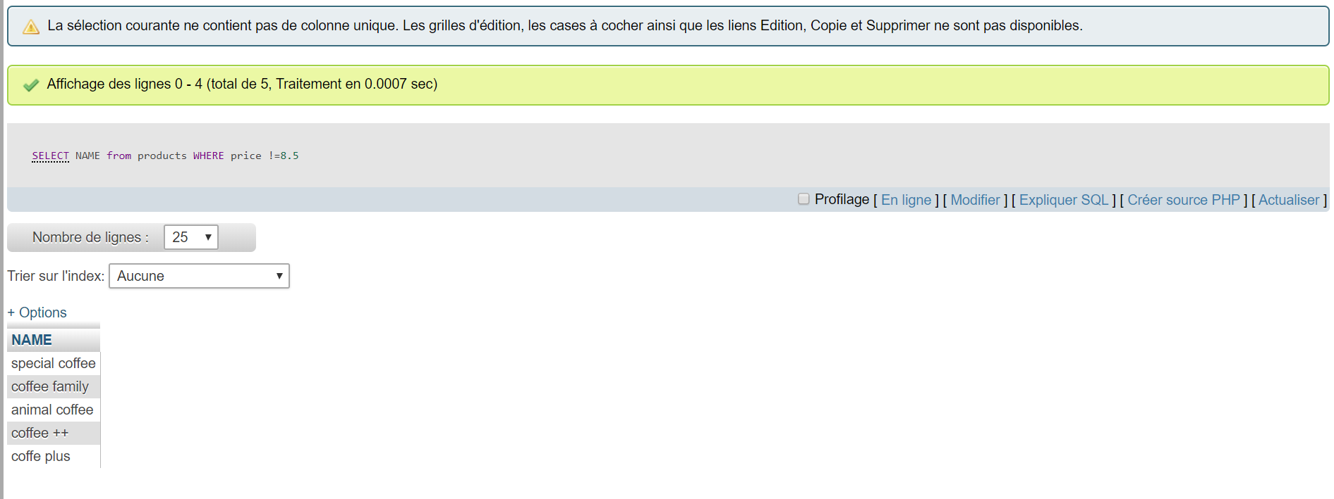

* the name and price of all products with a coffee origin Equal to Cuba or Indonesia. Ordered by name from A-Z:
* select NAME,price from products where product_origin = "Indonesia" or product_origin = "Cuba" order by NAME ASC;

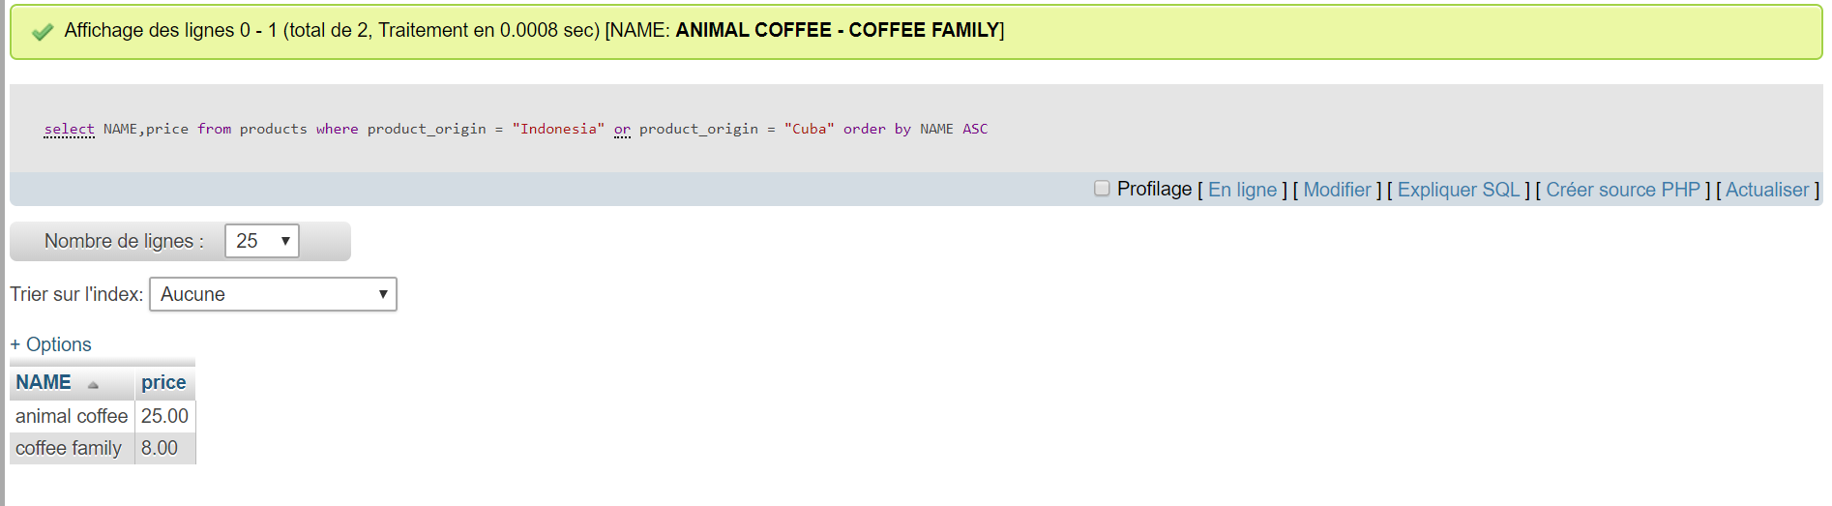

* the name, price and coffee origin but rename the price to retail_price in the results set:
* SELECT NAME,product_origin,price as retail_price FROM products;

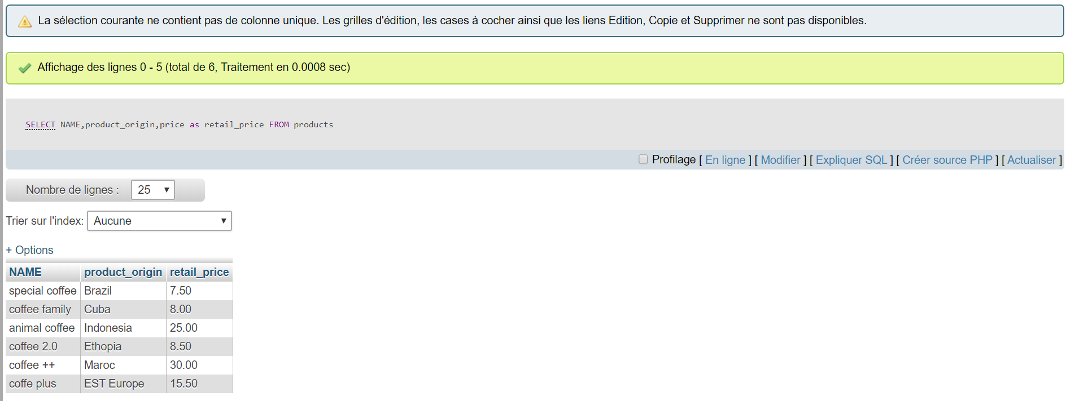

#2 Select from the table clients the following:

* the first name and phone number of all the females who have a last name of Bluth:
* SELECT FIRST_NAME,PHONE_NUMBER FROM clients

WHERE GENDER = "F" AND LAST_NAME LIKE "%BLUTH%";

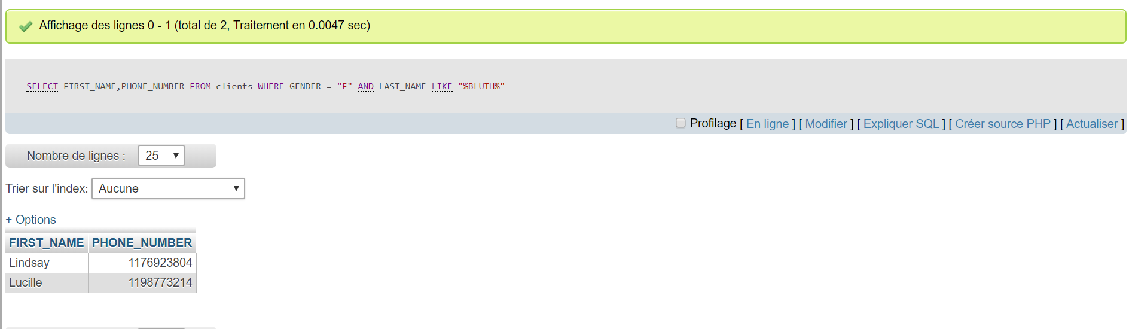

* How many male customers don’t have a phone number entered into the customers table:
* SELECT * FROM clients

WHERE PHONE_NUMBER is null;

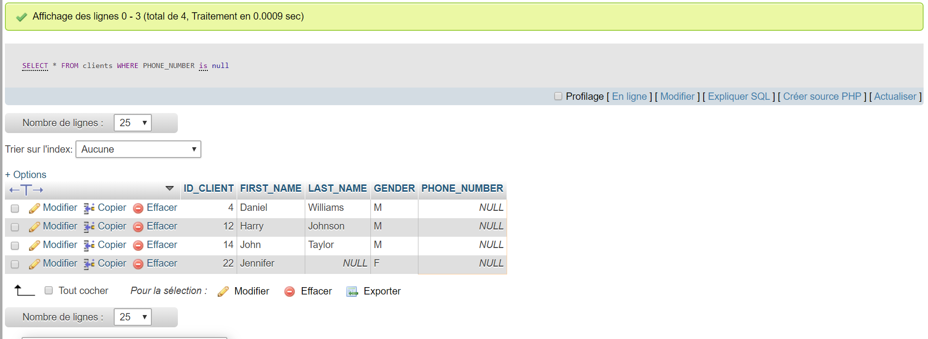

* the first name and phone number of all customers who’s last name contains the pattern ‘ar’:
* SELECT FIRST_NAME,PHONE_NUMBER FROM clients

WHERE LAST_NAME LIKE "%ar%";

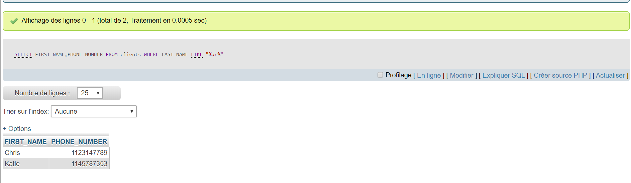

* select distinct last names and order alphabetically from A-Z:
* SELECT DISTINCT LAST_NAME FROM clients

order by LAST_NAME ASC;

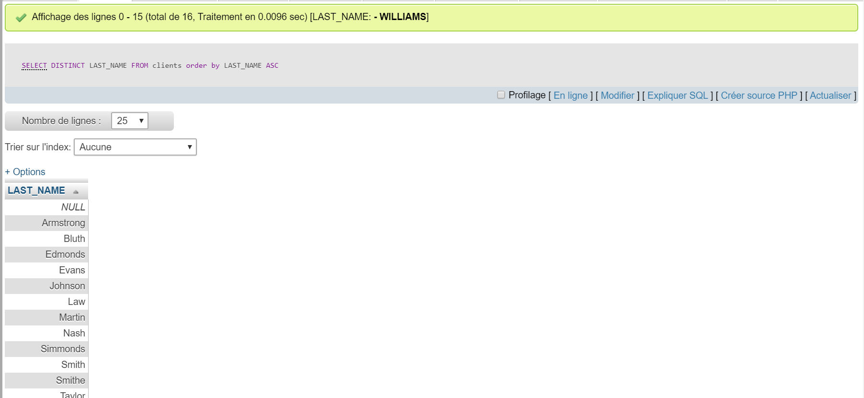

#3 Select from the table command the following:

* all the orders from February 2017 for customers with id’s of 2, 4, 6 or 8:
* select * from orders

where ID_CLIENT = 2 or ID_CLIENT = 4 or (ID_CLIENT = 6 or ID_CLIENT = 8);

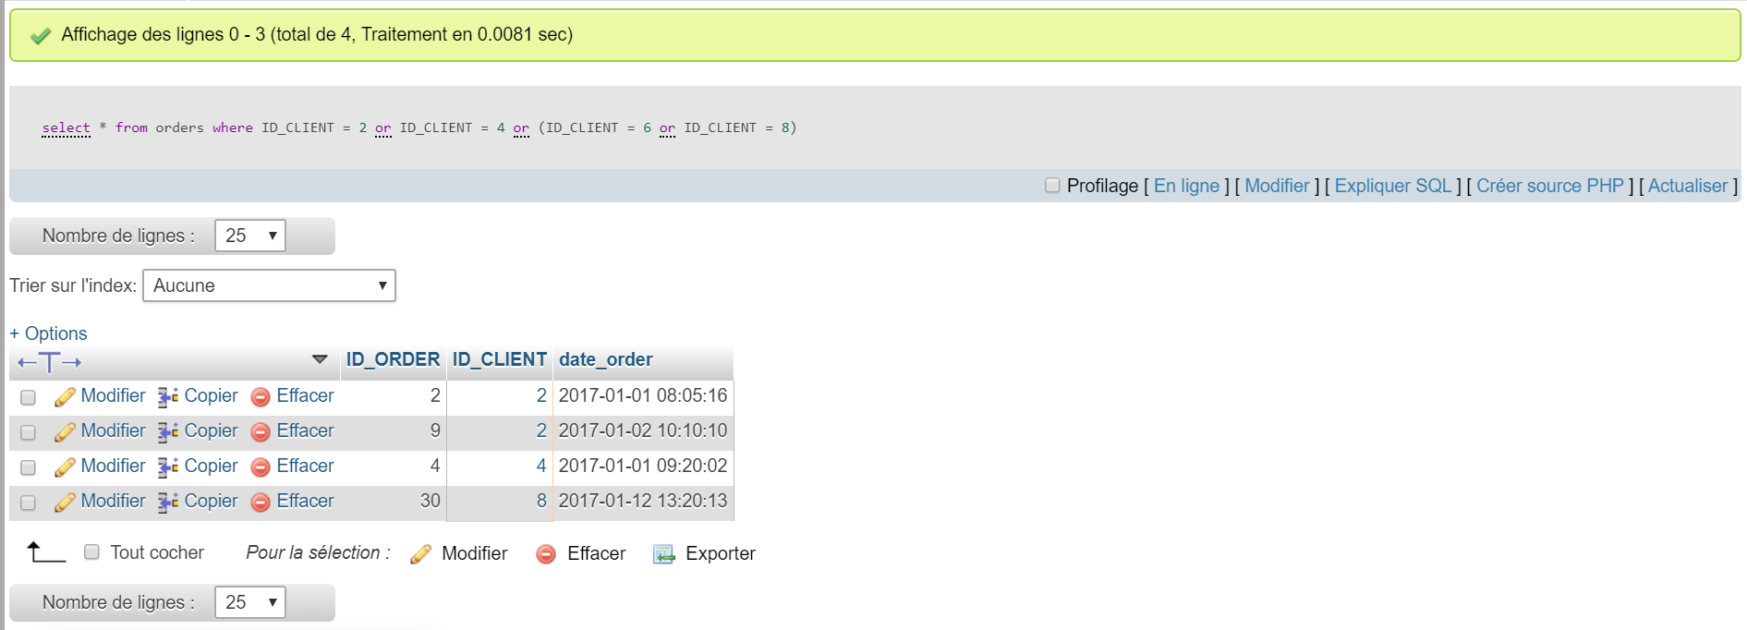

* the first 3 orders placed by customer with id 1, in january 2017:
* select * from orders

where ID_CLIENT = 3 limit 3;

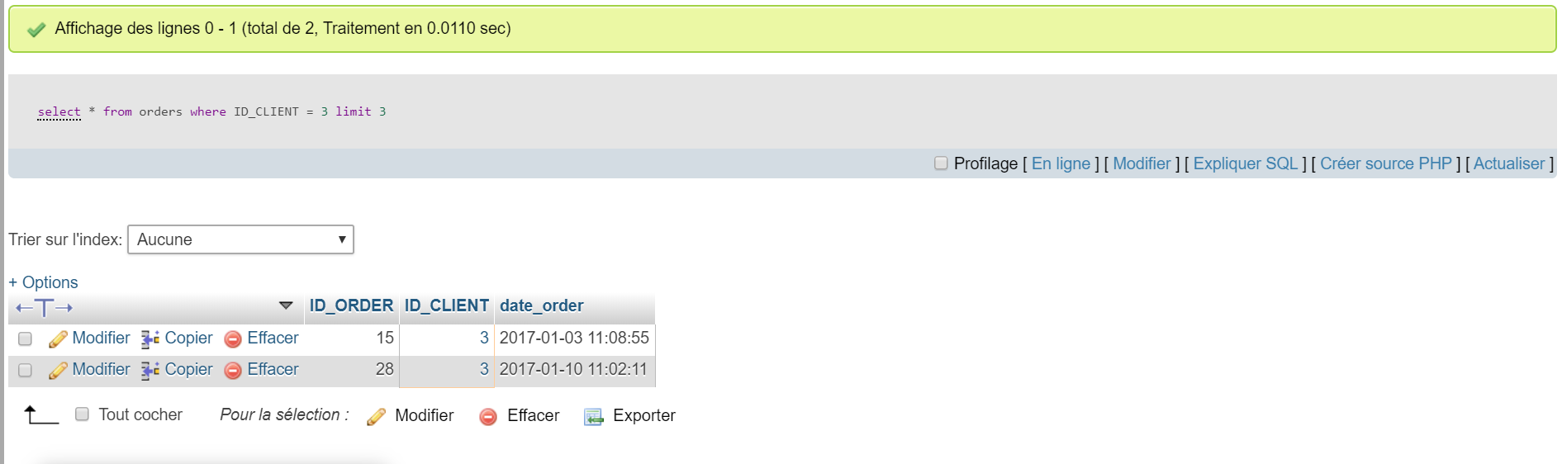

***#Step 5:***

*Multiple Selection using Joins:*

* Select the order id and clients phone number for all orders of product id 4:
* SELECT Orders.ID_ORDER,clients.PHONE_NUMBER FROM Orders

INNER JOIN clients

ON Orders.ID_CLIENT = clients.ID_CLIENT

AND Orders.ID_PRODUCT = 4;

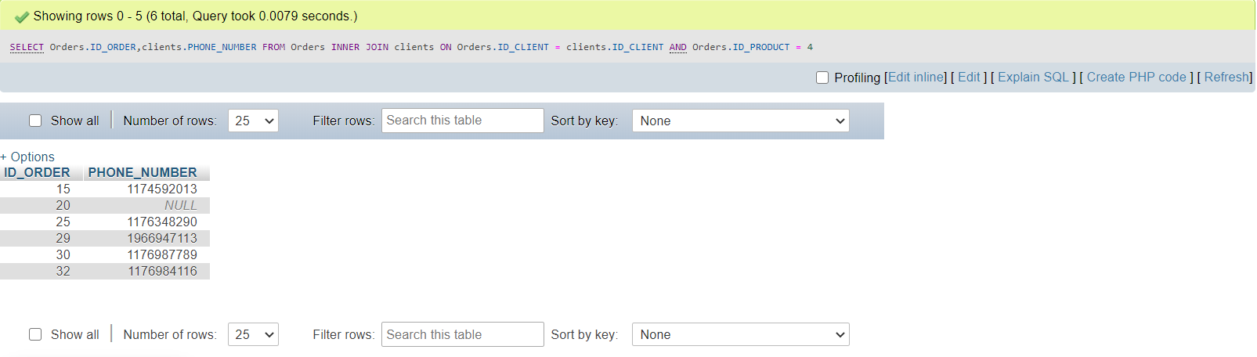

* Select the product name and order time for filter coffees sold between January 15th 2017 and February 14th 2017.
* SELECT products.NAME,orders.DATE_ORDER FROM orders

INNER JOIN products

ON orders.ID_product = products.ID_product;

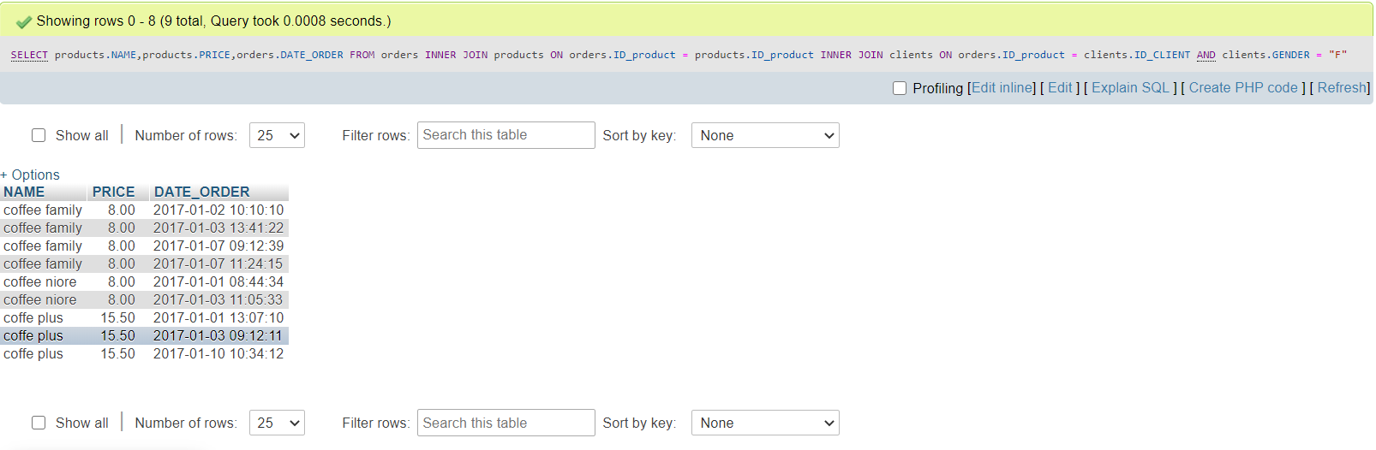

* Select the product name and price and order time for all orders from females in January 2017.
* SELECT products.NAME,products.PRICE,orders.DATE_ORDER FROM orders

INNER JOIN products

ON orders.ID_product = products.ID_product

INNER JOIN clients

ON orders.ID_product = clients.ID_CLIENT

AND clients.GENDER = "F";

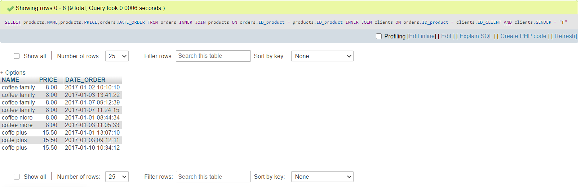

***Réalise par :***

***AYOUB EL JELLADI***

***#FIN#***